- \(…)\Strip transfer\Strip transfer-Unit C
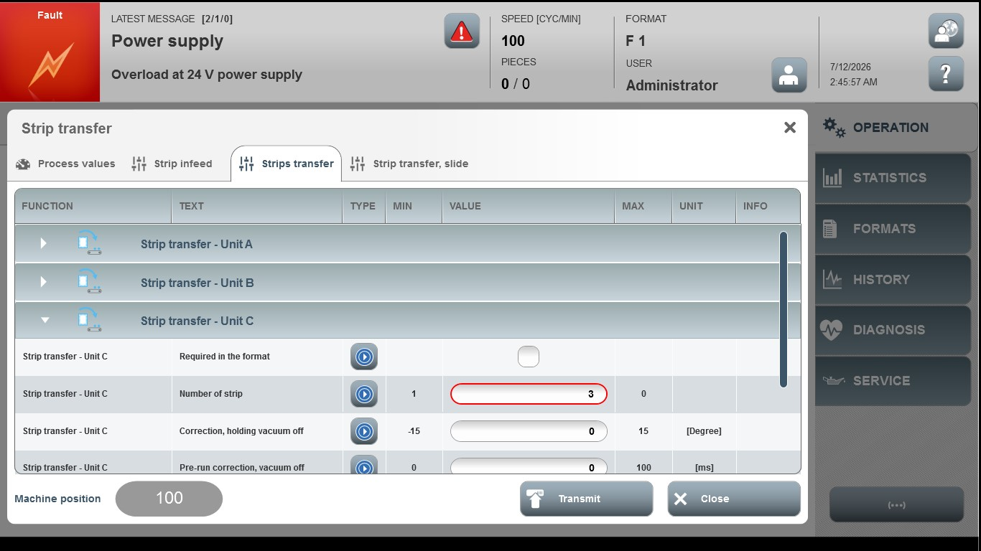
Acceptance criterion | Limits | Pass / Fail: Dev-No. | Date | Initials
Screen matches screenshot | N / A
Screen matches screenshot | N / A
Number of strip | 1…0
Correction, holding vacuum off | -15…15
Pre-run, correction vacuum off | 0…100

